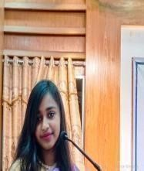
Jerin Akther Tumpa
tumpa11730531@gmail.com
+8801870895479
Gopalgonj,Bangladesh

SUMMERY

My name is Jerin Akther Tumpa and Iamexcited tointroduce as a newbie in the word of freelancing.Looking for entry level position, I hope to gain experience in the field .I am confident that with my determination and knowledge,I can becom a successful freelancer.My strengths include writing skills, creativity, and the ability to think outside the box. I am also can speak and read english. I am eager to learn from professionals and newcomers alike in this field. I’m driven to prove myself to be a reliable and competent freelancer. Thank you for your time. I look forward to working with you soon.

Skill Highlights

- HTML(6 month)
- CSS(6 month)
- Bootstrap(6 month)
- Tawilwin css(6 month)
Education

Exam | Institution | Passing Year | GPA
JSC | Shornokoli High School | 2016 | 3.90
SSC | Shornokoli High School | 2019 | 3.50
HSC | Shekh Fojilatunnesa Govt  Mohila Collage | 2021 | 4.17

